# Project Summary

The Kensington E-Lock Project is divided into three submodules: the physical housing, the electronics, and its accompanying software system. This product is designed to bring the existing Kensington E-lock design to a next level. The product will be mounted around the existing Kensington Lock and will make the usage of cable connecting to the lock optional. The E-Lock will be powered by battery, and since its electronics draw very little energy. This conclusion is drawn by calculations.

# Background

The first Kensington Lock was designed around 50 years ago, which is a time where the concept of Embedded Systems and Internet-Of-Things is nonexistent. Its original design solely provides protection by physically connecting the lock to a slot from computer and cable. The final setup can be extremely messy if an organization holds hundreds of computers and each of them connects to a Kensington Lock. A redesigning is needed to incorporate the technology into the lock. Currently, there is no security lock that has technology elements embedded into it on the current market, so we are the only group of people who are doing this, which makes our design unique but practical.

# Requirements

Most of the engineering specifications are listed in the posters. Some of them would be:

#### Mechanical Engineering Specifications

* Housing Size: 41.2mm * 43.9mm * 32.8mm

#### Electrical Engineering Specifications

* Electronics Footprint: 23.0mm * 19.5mm
* Maximum Battery: 22,727 hours or around 947 days

#### Software Engineering Specifications

* Qt Framework5.15LTS and QtQuick 2
* Android Support: Android NDK Version 21+
* Microsoft Windows Support: Windows 10 1905+
* Adaptive Font and Component Size
* Separate UI Thread and Bluetooth Service Thread

# Preliminary

As the Kensington E-Lock project is being developed concurrently with this course, a final design is available. All individual preliminary prototypes are included in this poster.

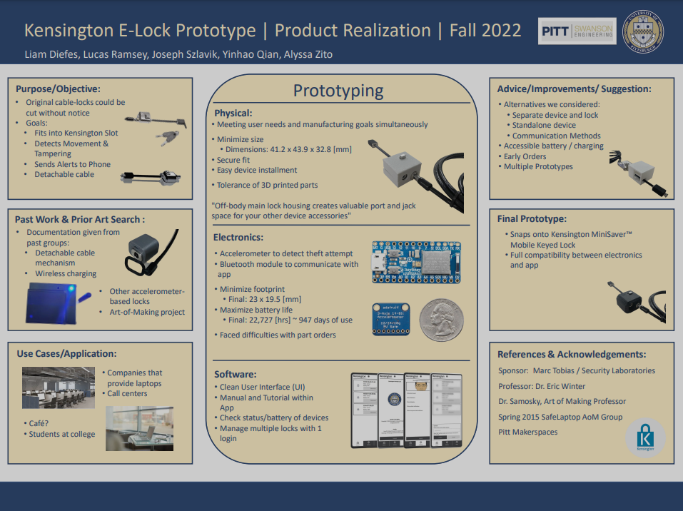

# Expected Problem

During our development iterations, many problems arose.

#### Mechanical Engineering Problem

* How to select the right material so that is solid enough but does not create a faraday cage that blocks the bluetooth signals？
* How to prevent users from accessing the internal circuitries from charging ports (if charging is needed)？

#### Electrical Engineering Problem

* How to select the right battery so that it will be small enough to fit into the housing and capable of not dying for a long period of time?
* What should be the critical point of the amount of motion being detected which a tempering notice will be pushed?

#### Software Engineering Problem

* How should I achieve the local bluetooth MAC address on the current device as on both Windows and Android it’s impossible to retrieve bluetooth meta-data programmatically.
* What protocols should the bluetooth use ? Classic Bluetooth or Bluetooth Low Energy? Should two devices communicate through Bluetooth Socket or GATT Characteristics and Services?
* What Bluetooth UUID should be used? There is no standard UUID for “tempering status” defined by IEEE.

# Team

Apart from me, there are four people in our group: one is a bioengineering major, one is electrical engineering major, and the other two are mechanical engineering majors.

| **Major** | **Roles** |
| --- | --- |
| Bioengineer | * Provide project management * Manage time planning * Components integrations |
| Electrical Engineer | * Configure the accelerometer and bluetooth modules * Solder the printed circuit board. |
| Mechanical Engineer | * Design housing 3-d model * Inquire housing material usages |
| Computer (Software) Engineer | * Unify communication protocols * Develop client applications * User interface design |

# Reference

No references are made in this report.

###### 